PROJECT TITLE : NOISE POLLUTION MONITORING

PHASE :3 : DEVELOPMENT PART -1

TEAM MEMBERS:

913021104035-TAMIZHSELVAN S

913021104034-SRIKRISHNARAJAN N

913021104029-SHIEKABUTHAHEER S

913021104017-NIRMALA M

Noise pollution monitoring is the process of measuring and analyzing noise levels in an area to assess its impact, identify sources, and develop strategies for noise reduction and compliance with regulations

WOKWI :

Wokwi is a versatile online platform that allows you to design ,simulate, and test electronic circuits in a virtual environment.

Website (<https://wokwi.com/arduino>)

Components Required :

1. ESP32(Micro controller)
2. Sound sensor

To monitoring noise pollution , you typically need a set of equipment and software to capture ,analyse and report sound levels .The above mentioned are some basis list of components required for noise pollution monitoring once you have these components ,you can set up a monitoring stations ,take measurements ,and analyse the data to draw conclusion about noise pollution in a specific area

Wiring connections

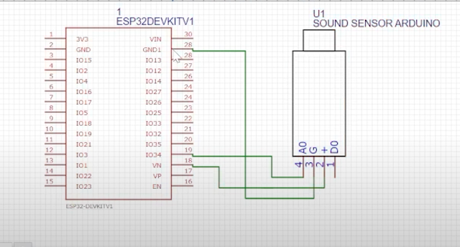

Microphone :

A specialized microphone that captures sound accurately and is manually part of the SLM.

ESP32(Micro controller):

ESP32 is a versatile microcontroller with wireless connectivity, ideal for a wide range of applications.